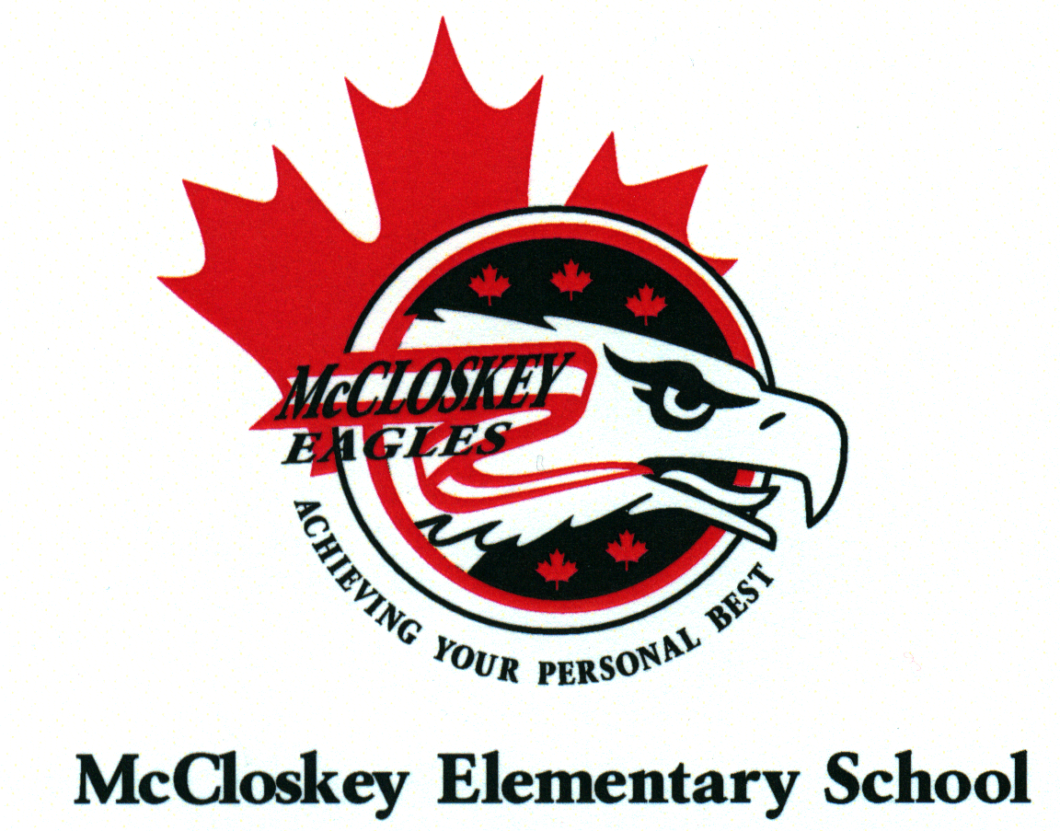
MCCLOSKEY FAMILY NEWSLETTER
Issue 9 http://mc.deltasd.bc.ca
May 6, 2019
Office: 604-596-9554 Absentee Line 604-878-5395
Dear McCloskey families,
With only 8 more weeks of school, we are focused on building grade level skills in each classroom and preparing for some field trips. At this time of year, we also are preparing for the next year. A number of factors go in to ensuring an appropriate placement and the class configurations for next year: the number of students in a grade; the gender of the students; the learning styles; and the specific needs of the students are all factors that are looked at when determining placement. The vast majority of parents leave the decision regarding class placements in the knowledgeable hands of the staff at the school. We do take into consideration parent input as well, but need to ensure that all understand it is not possible to accommodate all requests. If you feel it is important to offer additional information, please do so in a respectful manner that highlights the needs of your child(ren). A letter will be sent home this coming week outlining the process parents are expected to follow if they wish to supply us with information that may help us in class placements for next fall. Letters will be accepted until June 10th via email (bnelmes@deltasd.bc.ca ) or in written form submitted to the school office. Please read through the Student Placement information letter carefully before submitting a request. Thank-you!
Are you Moving? Do you know of New Families in the McCloskey area?
If you plan to move over the summer we will miss you and we wish you well in your new location. It would be very helpful for us if you would let the office know of your plans. Also, if you know of any new students (or students wishing to return to McCloskey) please ask them to call or come in to register as soon as possible. Thank you in advance for your consideration and your help with this. We want to work with accurate numbers as we begin the planning process for the 2019-2020 school year.

Purdy’s Chocolate bar Fundraiser
Please return all money or unsold boxes of chocolate bars to the Office asap as the final Prize draw will take place Tuesday, May 7th.

Mondays, May 6, 13, & 27 | Yo Bro/Yo Girl in the gym
Wednesday, May 8 | Regional Track meet
Thursday, May 9 | 7 pm PAC Annual General meeting
Sunday, May 12 | Mother’s Day!
Monday, May 13 | 9:30-11:30 am Final Kindergarten Explorations session
Thursday, May 16 | District Track meet
Friday, May 17 | Pro. D. day (day off in lieu of summer Pro. D.)
Monday, May 20 | Victoria Day (schools closed)
Thursday, May 23 | Hot Lunch (hot dogs)
Friday, May 31 | 1 pm Talent Show (parents are welcome to attend)
Friday, June 14 | Sports Day and Hot Lunch day
Sunday, June 16 | Father’s Day
Monday, June 24 | Grade 7 Luncheon
Thursday, June 27 | Final Assembly – honouring our Grade 7’s
Thursday, June 27 | Final day **All Students dismissed at 10:30am**

Parent Advisory Committee (PAC)
All parents/guardians of students at our school are members of the PAC. Meetings are open to everyone. Meetings are monthly either after school (3:15pm) or in the evening (7:00pm). The next meeting is May 9th at 7pm in the Library. We have a number of Exec. Members who will be moving on and are not able to continue as their children are going to high school next year. We need new Executive members (Chair, Secretary and Treasurer) to fill their spots. Training is available. These volunteer positions are vital to having an active PAC. Without this, our PAC will be suspended including our funds ($15,000 plus). Please consider getting involved!
Warm Weather Clothing
With the warmer weather now upon us, students are often tempted to wear “beach-like” clothing to school. Please help us to maintain an appropriate and respectful learning environment at the school by ensuring that the following are not worn to school:
- Low-cut, strapless, spaghetti straps, or midriff-revealing tops (modest tank tops are fine).
- Very short or low-rise shorts/skirts (No shorter than fingertips with hands at side).
- Shirts or hats with inappropriate slogans.
As well, students who wear sandals or flip-flops tend to be more injury prone on the playground and find it difficult to participate safely in daily physical activity. Because of this, it is preferred that students wear footwear appropriate for running and exercising to school.

Kindergarten Explorations
Children registered for Kindergarten are invited to come to 4 sessions of Kindergarten readiness. Please pass on this information to families you know. Call the school to register.
Mondays: April 8, 15, 29 and May 13th
9:30 – 11:00 am in the Library
- Children will participate in activities to help them prepare for Kindergarten in a Kindergarten room.
- Parents must attend with the children.
- The children will be given some time with the teacher and will help them develop independence and confidence before they come to McCloskey in September 2019.

Lost and Found
- Our Lost and Found box is overflowing once again. There are many jackets in the box that had been left outside or in the gym. If your child is missing anything, please come take a careful look. It may be here after all!

Next Year’s School Calendar (2019/20)
We have a DRAFT School Calendar and are awaiting District approval. Please watch for this to be sent home prior to the end of May. If you have any questions (or are planning well in advance), please see us at the school office.

Community Resources for Families

GEERING UP Summer Day Camp (run by UBC but held in North Delta)
- Week-long
- $260
- 25%, 50%, 75%, and 100% bursaries available…apply now! Round 2 deadline: May 10th
- Grades 2-7 (current grade 1-6’s)
- Location: Trinity Lutheran Church, 11040 River Rd, Delta
Geering Up camps are all about making Science, Technology and Engineering hands-on and exciting. Each day is a dynamic mix of hands-on activities, demonstrations, tours, mentors, and design challenges. Our camps are taught by experienced university students with a passion for their field of study. In addition to all of this, we ensure each camper spends, at least, one hour of each day participating in active games outside.
For more information -- https://www.geeringup.apsc.ubc.ca/camps/delta-steam-camps/

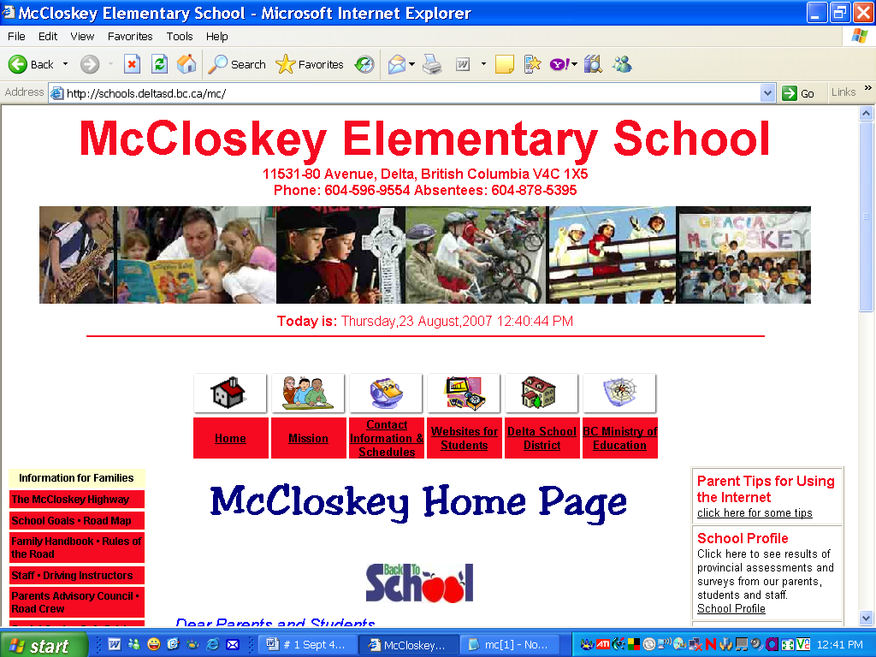
McCloskey Website and blog
Parent newsletters will be posted on the McCloskey’s Web Page (http://mc.deltasd.bc.ca).

Yours truly,

Mrs. B. Nelmes Mrs. B. Bryan
Principal Vice Principal

MISSION STATEMENT
At McCloskey we are dedicated to providing
a positive, safe, and caring learning environment
which encourages high standards, mutual respect, and personal responsibility.
With school, home and community working together we encourage all students
TO ACHIEVE THEIR PERSONAL BEST
in acquiring the knowledge, skills and attitudes needed to become productive citizens.

Do you have any Feedback/Questions/ Concerns? You can call us at the school or email us… bnelmes@deltasd.bc.ca or bbryan@deltasd.bc.ca

